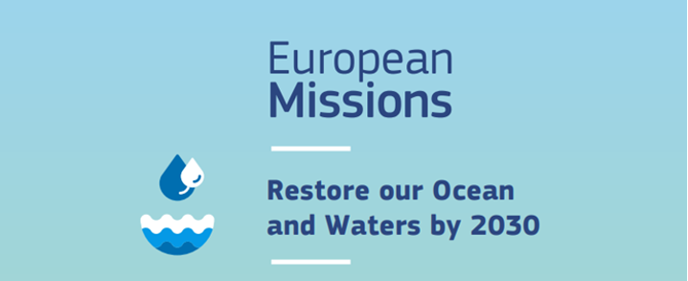Policy Support
16 June 2023

INFO DAY
EU Mission: Restore Our Ocean and Waters by 2030
University of Bucharest, Ioan Mihăilescu Hall
address: 90 Panduri Street, 1st Floor

AGENDA

09:00 - 09:30 | Registration of participants
09:30 - 10:00 | Welcome and opening remarks  Moderator: Laura Urdes, EU Mission NCP – Restore our Ocean and Waters  - Marian Preda, Rector - University of Bucharest  - Andrei Alexandru, State Secretary – Ministry of Research, Innovation an Digitalization  - Teodora Preoteasa, State Counselor - Prime Minister Cabinet
10:00 - 10:30 | EU Mission Ocean-related projects at University of Bucharest & Mission Ocean Competence Center (C9 - NRRP, I5)  - Carmen Chifiriuc, Vice-rector for Research - University of Bucharest  - Corina Bradu, Coordinator - Mission Ocean Competence Center
10:30 - 11:00 | Mission Ocean, seas and waters: Work Programme 2023 – 2024 – main features  - Andreea Strachinescu, Head of Unit - DG MARE, European Commission
11:00 - 11:15 | Q&A session
11:15 - 11:30 | Break
11:30 -12:00 | The BlueInvest Platform – An Ocean of Opportunities  - Andreea Strachinescu, Head of Unit - DG MARE, European Commission
12:00 - 13:00 | Romania Participation in past calls – Sharing Good Practices  ERA-Net_Rus BS STEMA - Changes in storminess and coastal erosion induced by climate variability along the Black Sea coasts. Management and Adaptation  - Alfred Vespremeanu-Stroe - University of Bucharest  MARCOBOLO - MARine COastal BiOdiversity Long-term Observations  BIOAGORA - Bio Knowledge Agora: Developing the Science Service for European Research and Biodiversity  Restore4Life - Restoration of wetland complexes as life supporting systems in the Danube Basin  - Mihai Cristian Adamescu - University of Bucharest  Danube4all  - The GeoEcoMar team
13:00 - 13:45 | Light walking lunch
13:45 - 14:15 | Financial regulations and best practices, Horizon Europe - What we have to be careful about (online)  - Cristina Anania, NCP - Legal & Financial guidelines
14:15 – 14:30 | Q&A session
14:30 – 15:00 | How the RO NCP team can support you  - Laura Urdes, EU Mission NCP – Restore our Ocean and Waters
15:00 – 15:10 | Closing remarks

