
Microbial Biosystem X(X): X–X (2025) http://mb.journals.ekb.eg ISSN 2357 0334

Template 2026

A Word file of the manuscript (The template can be downloaded here), single-spaced, with font 11, preferably Times New Roman, with at least 20-mm margins on all sides should submitted to the submission page. Papers must be submitted in WORD with the text line numbered in the left margin, to facilitate the review process.
The content of any submissions should be original and must not be submitted simultaneously for consideration for publication in any other conference or journal. All submissions will be checked against the plagiarism checker.
One complete set of illustrations comprising original line drawings and first-class photographic prints intended for use by the printer in preparing the published version of your paper (identify each separate item with your name and short title of the paper). Mounted illustrations Must Not exceed A4 in size.
A covering letter that clearly states the name and address of the person with whom the Editors should correspond, and which confirms explicitly that (a) all named authors have agreed to the publication of the work, and (b) the manuscript does not infringe any other person's copyright or property rights.
The names of 3-5 referees are not in your institution with appropriate expertise who might be considered as possible referees for your paper.

Example
Genus Aspergillus in Tunisia (Times new Roman, 16 pt, bold)

Ahmed M. Abdel-Azeem^{1,2*}, Lobna Hajji-Hedfi³, Bassem A. Balbool (Names of Authors with initials, Times new Roman, 14 pt, bold)

¹ The affiliation and address of the author without abbreviations and email (Times new Roman, 10 pt, Italics)
² Etc
³ Etc

ABSTRACT (Times new Roman 11pt, bold)
The abstract should be concise and provide the basic findings of the study. No abbreviations, author citations or reference citations should be included. (Times New Roman, 11 pt)

Keywords (Times new Roman, 11 pt, bold) – in alphabetical order – must not repeat words in title (Times New Roman, 10 pt)

INTRODUCTION
Citations are listed in chronological order (von Arx & Müller 1954, Ball 1987, 2007, Tall et al. 2006). The introduction should briefly review the topic being investigated and present the objectives of the study. [Note: ‘&’ not ‘and’; no comma after authors; comma to separate citations] (Times New Roman, 11 pt)

MATERIALS AND METHODS

Isolates and Morphology
The methods should be adequately detailed or referenced in other work.
All subheadings should be in the same format. (Times New Roman, 11 pt)

RESULTS
This can have subheadings (Fig. 1). There should be no reference citations in the results (Figs 2, 3, 6–8). (Times New Roman, 11 pt)
Statistical treatment of results. Numerical data which lack statistical analysis are valueless and will not be published. Data from a sufficient number of independent experiments should be reported to permit evaluation of the reproducibility and significance of results. When any significance is claimed, the test of significance used should be stated, and an estimate of the probability given. If you use complex statistical transformations a few lines of explanation in plain English of the purpose and the outcome of the test should be provided.

Phylogenetic analyses
The results section should only include the results of this study and no comparison with other studies. Never use the term etc. in the text. For new species and genera use the format below.

Colletotrichum pseudotheobromae McKenzie, sp. nov. Figs 12–18
Index Fungorum number: IFXXXX; Facesoffungi number: FoFXXXX
Etymology – named for its resemblance to C. theobromae.
Conidiomata formed on poplar twigs in culture pycnidial, uniloculate, dark brown to yellow-black or reddish green, immersed in the host becoming erumpent when mature…..
Teleomorph – Glomerella tingliae (Cooke) Arx, Gen. Fungi Sporul. Cult.: 143 1970. Follow Index Fungorum.
≡ Physalospora tingliae Cooke, Grevillea 17: 92 1889.
Known distribution – widespread in tropical and subtropical regions.
Material examined – Country, Province, Town, place, on substrate, (date) 15 Jul 2009, (collector) P.J. Smith, collectors’ number (herbarium, state if holotype or other type) – ex-type culture in CBC
Notes – The connection….

Key to Microbial species
1. Text Text Text Text Text
2. Text Text Text Text Text Text Text Text
3. Text Text Text Text Text Text Text Text

DISCUSSION
This is where you compare your work with other research and put forward and discuss your major findings (Table 1). There must be adequate comparison and references to previous work. (Times New Roman, 11 pt)

Table 1 Conidial size and septation of selected Colletotrichum species.
 | Magnolia liliifera |  | Cinnamomum iners
 | Stage I* | Stage II* | Stage I* | Stage II*
Species richness | 23 | 21 | 14 | 9
Species evenness | 88 | 44 | 24 | 17
Shannon indices | 2.84 | 2.9 | 2.56 | 2.1
Shannon evenness | 0.74 | 0.84 | 0.92 | 0.9

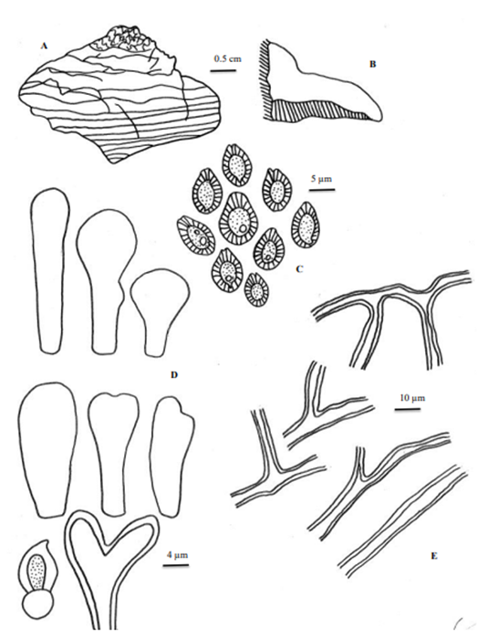

Fig 5. Ganoderma brownii (NJS23) (A) Basidiome showing pilear surface (B) Transverse section of basidiome showing context and stratified tube layers (C) Basidiospores (D) Cuticle (E) Skeletal and binding hyphae.

CONCLUSION
This is where you conclude your work (Times New Roman, 11 pt)

CONFLICT OF INTEREST STATEMENT
The authors declare that they have no conflict of interest. (Times New Roman, 11 pt)

ACKNOWLEDGEMENTS
This work was financed by the European…. (Times New Roman, 11 pt)

REFERENCES (Note: If there are more than 8 authors, write first 6 authors names followed by et al.)

Alfaro ME, Zoller S, Lutzoni F. (2003). Bayes or bootstrap? A simulation study comparing the performance of Bayesian Markov chain Monte Carlo sampling and bootstrapping in assessing phylogenetic confidence. Molecular Biology and Evolution 20, 255–266.
Anon (2001-2009). NZFungi database of New Zealand fungi. Landcare Research, New Zealand. http://nzfungi.landcareresearch.co.nz (Accessed on May 14, 2013).
Arx JA von (1981). The Genera of Fungi Sporulating in Pure Culture. J. Cramer, Vaduz.
Doi:……..
Piasai O, Manoch L. (2009a). Coprophilous ascomycetes from Phu Luang Wildlife Sanctuary and Khao Yai National Park in Thailand. Kasetsart Journal (National Sciences) 43, 34–40.
Piasai O, Manoch L. (2009b). Diversity of microfungi from animal excrement at Ko Samaesarn and Mu Ko Angthong National Park; 35th Congress on Science and Technology of Thailand. Department of Plant Pathology, Faculty of Agriculture, Kasetsart University, Bangkok.

Note: Page margins must be 2.0 cm each side
Page size must be A4
Single spacing

